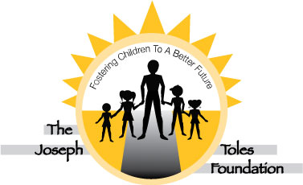
The Joseph Toles Foundation

18 Robin Drive
Huntington, New York 11743
(631) 470-6062 / (917) 532-8694

Officers

Joseph Toles
President

Nancy Ochsenreiter
Senior
Vice-President

Joan Verardo
Vice-President of Development

Linda Averbuch
First Treasurer

Richard Zaweski
Second Treasurer

Sharon Hinkson
Recording Secretary

Mary Lambert
Corresponding
Secretary

Suzanne Legge
Marketing Secretary

Directors
Carolyn Barnard
Josephine Pizzurro
Suzanne Stone

Executive Director
Joseph Toles

HELP SEND A FOSTER CHILD TO CAMP

The Joseph Toles Foundation® envisions a day when children from all walks of life, all creeds and colors and all economic backgrounds are encouraged and nurtured to discover their own potential and individuality. The mission of the Joseph Toles Foundation® is to provide support, leadership and social skills development workshops, retreats and camping experiences to children from all walks of life.

Please consider making a tax deductible donation where every penny of it will be spent on giving a foster child the opportunity to attend our camp. A donation of $500 will send a foster child to camp for a full week. Any amount that you can give will be used directly to send a foster child to camp this summer.

We thank you in advance for your generous support of our foundation and its mission to help foster children lead a fulfilling life.

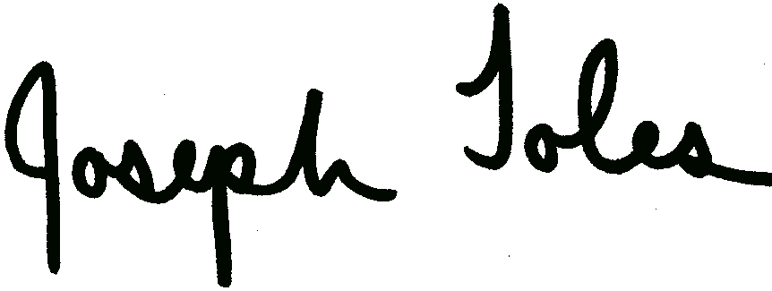
Joseph Toles, LMHC President and Founder

E-Mail: TolesFoundation@aol.com Website: www.JosephTolesFoundation.com

I would like to contribute a tax deductible donation to the Joseph Toles Foundation for:

$500 (sends one child to camp) $200 $250 $100 $75 $50 $ ___ other amount

Name:

Address: City: State: Zip:

Phone: ( ) – Email:

Use our Pay Pal link at JosephTolesFoundation.com

